Case 9-MEX-Chinesco-Shaman

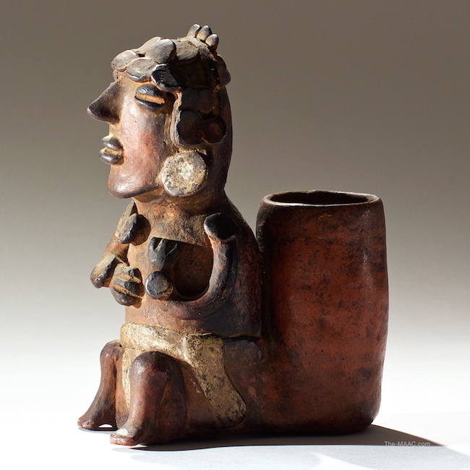

Pre-Columbian pottery figure of a priest from Colima. Pottery, Mexico, 100 B.C. H: 9″ [Palmyra Heritage: Gallery 16/212.319.1077]

We all know of the Aztecs and their towering relics. Many are less familiar with the far older cultures of Western Mexico who left no monuments or writing systems but whose [shaft tomb culture](https://en.wikipedia.org/wiki/Western_Mexico_shaft_tomb_tradition) produced the most dramatic artworks in Mesoamerica. Small in stature but bursting with artistry, Mexican tomb pottery is our one key to the cultures of ancient West Mexico.

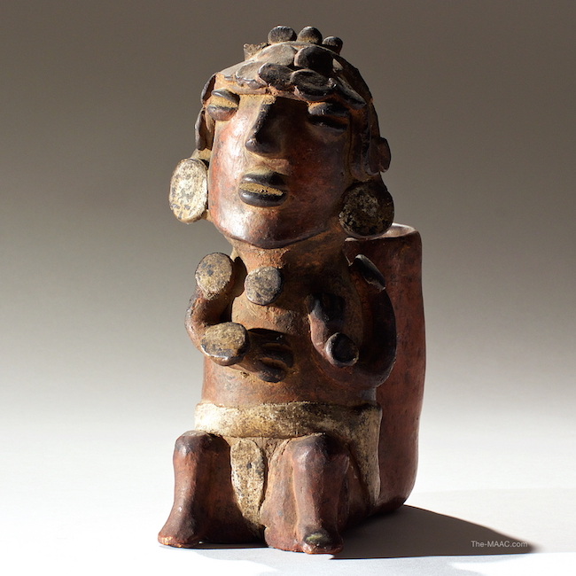

Frontal view of Pre-Columbian Colima priest figure, whose rear basket likely functioned as a food or drinking vesse